Summary

File
Html file:

```sh

```

Content

Ideation
❯ /rename mlb - idk
⎿ Session renamed to: mlb - idk

❯ ok so next i wanna start modeling another MLB market, thoughts on good ones
to look into?

Searched for 5 patterns (ctrl+o to expand)

⏺ Available markets not yet modeled: batter_hits, batter_home_runs, batter_rbis,
batter_runs_scored, batter_strikeouts, pitcher_earned_runs,
pitcher_hits_allowed.

Top 3 worth looking into, ranked:

1. batter_strikeouts — strongest candidate. It's the mirror of
pitcher_strikeouts which already found edge. Key predictors (opp pitcher K/9,
batter K%, handedness matchup) are highly stable and already partially
computed in your pitcher strikeouts pipeline. Market probably hasn't fully
priced in the specific pitcher-batter matchup on a given day.

2. batter_hits — very high volume (every starter in every game). UNDER 0.5
(no-hit game) is a ~70% base rate event so there's natural cushion. Harder to
model than strikeouts because hits are BABIP-influenced (luck), but matchup
quality and pitcher contact suppression rate are real signals.

3. pitcher_hits_allowed — reuses the pitcher outs framework directly.
Downside: also BABIP-dependent which caps ceiling on model accuracy. Probably
weaker signal than strikeouts or batter Ks.

I'd start with batter_strikeouts — you already have the pitcher K data, the
modeling setup is nearly identical to pitcher_strikeouts, and the market
volume is high. Want to kick off a data pull to check Odds API coverage and
line distribution?

✻ Baked for 59s

Plan to start

❯ yeah lets check this one out. give me a plan

⏺ Plan: batter_strikeouts research

---
Step 1 — Coverage check (do this first, go/no-go gate)
Pull batter_strikeouts historical odds from the Odds API and check:
- Seasons available and row count
- % of games with market coverage (pitcher_walks died here at 43%)
- Line distribution: 0.5 vs 1.5 vs alternate lines
- Books per event (depth of market)

If coverage is thin (<60% of games) or it's mostly a single book, stop here.

---
Step 2 — Actuals
Pull batter-level game logs (K per game) from MLB Stats API or
pybaseball/Statcast. Same grain as pitcher logs — one row per batter per game.
Need at least 2 full seasons.

---
Step 3 — Feature build
Core predictors:
- batter_k_rate_L20 — rolling 20-game batter K rate (season-scoped, shift(1))
- opp_pitcher_k9_L5 — opposing starter's rolling K/9 (already computed in
pitcher_strikeouts pipeline — reuse)
- handedness_matchup — L/R batter vs L/R pitcher splits
- min_line, max_line, consensus_line
- game_total, is_home (from existing game lines parquet)

---
Step 4 — EDA
- Raw under/over hit rates by line (0.5 vs 1.5)
- Check market efficiency: does high-K pitcher correlate with higher batter K
line? (if yes, market is pricing it — need model to find residual edge)
- Distribution of actual Ks vs posted lines

---
Step 5 — Model + OOS backtest
OLS first, then XGB if OLS shows signal. Same leave-one-season-out grid search
as pitcher_outs/total_bases: sweep sigma × shrinkage × min_edge ×
side_policy.

---
Biggest unknowns going in:
1. Coverage % — the make-or-break gate
2. Whether opp pitcher K rate is already fully priced in (market may be
sharper here than on pitcher props)
3. Whether 0.5 or 1.5 is the primary line — changes the modeling approach
significantly

Start with Step 1 — want me to write the coverage check script now?

✻ Cogitated for 29s

※ recap: Exploring a new MLB batter strikeouts prop model. Just drafted the
research plan — next step is writing the Step 1 coverage check script to pull
historical batter_strikeouts odds and confirm market depth before committing.

Coverage check

```sh
cd ~/dev/betting

echo "========================================"
echo "Starting coverage check..."
start_time=$(date +%s)

python src/mlb_batter_strikeouts_modeling/scripts/20260711_fetch_coverage_check.py

python src/mlb_batter_strikeouts_modeling/scripts/20260711_fetch_coverage_check.py --seasons 2026

end_time=$(date +%s)
elapsed=$((end_time - start_time))

echo "========================================"
echo "Completed in ${elapsed}s"
echo "========================================"
```

Out:

```
Last login: Sat Jul 11 00:31:00 on ttys060
thomasmyles@CHI-R7L1C2L5X ~ %
thomasmyles@CHI-R7L1C2L5X ~ % cd ~/dev/betting
python src/mlb_batter_strikeouts_modeling/scripts/20260711_fetch_coverage_check.py

^CTraceback (most recent call last):
File "/Users/thomasmyles/dev/betting/src/mlb_batter_strikeouts_modeling/scripts/20260711_fetch_coverage_check.py", line 39, in <module>
import pandas as pd
File "/Users/thomasmyles/.pyenv/versions/3.13.3/lib/python3.13/site-packages/pandas/__init__.py", line 49, in <module>
from pandas.core.api import (
...<62 lines>...
)
File "/Users/thomasmyles/.pyenv/versions/3.13.3/lib/python3.13/site-packages/pandas/core/api.py", line 28, in <module>
from pandas.core.arrays import Categorical
File "/Users/thomasmyles/.pyenv/versions/3.13.3/lib/python3.13/site-packages/pandas/core/arrays/__init__.py", line 1, in <module>
from pandas.core.arrays.arrow import ArrowExtensionArray
File "/Users/thomasmyles/.pyenv/versions/3.13.3/lib/python3.13/site-packages/pandas/core/arrays/arrow/__init__.py", line 5, in <module>
from pandas.core.arrays.arrow.array import ArrowExtensionArray
File "/Users/thomasmyles/.pyenv/versions/3.13.3/lib/python3.13/site-packages/pandas/core/arrays/arrow/array.py", line 63, in <module>
from pandas.core.arrays.base import (
...<2 lines>...
)
File "<frozen importlib._bootstrap>", line 1360, in _find_and_load
File "<frozen importlib._bootstrap>", line 1331, in _find_and_load_unlocked
File "<frozen importlib._bootstrap>", line 935, in _load_unlocked
File "<frozen importlib._bootstrap_external>", line 1022, in exec_module
File "<frozen importlib._bootstrap_external>", line 1118, in get_code
File "<frozen importlib._bootstrap_external>", line 1217, in get_data
KeyboardInterrupt

thomasmyles@CHI-R7L1C2L5X betting %
thomasmyles@CHI-R7L1C2L5X betting %
thomasmyles@CHI-R7L1C2L5X betting %
thomasmyles@CHI-R7L1C2L5X betting % cd ~/dev/betting

echo "========================================"
echo "Starting coverage check..."
start_time=$(date +%s)

python src/mlb_batter_strikeouts_modeling/scripts/20260711_fetch_coverage_check.py

end_time=$(date +%s)
elapsed=$((end_time - start_time))

echo "========================================"
echo "Completed in ${elapsed}s"
echo "========================================"
========================================
Starting coverage check...

=== Season 2024 (2024-03-20 → 2024-10-01) ===
2024-03-21 San Diego Padre @ Los Angeles Dod props= 52 credits=3,671,111
2024-03-28 Milwaukee Brewe @ New York Mets no lines (marked)
2024-03-28 Atlanta Braves @ Philadelphia Ph no lines (marked)
2024-03-28 Los Angeles Ang @ Baltimore Oriol props= 50 credits=3,671,090
2024-03-28 Detroit Tigers @ Chicago White S props= 52 credits=3,671,070
2024-03-28 Washington Nati @ Cincinnati Reds props= 54 credits=3,671,050
2024-03-28 New York Yankee @ Houston Astros props= 54 credits=3,671,030
2024-03-28 Minnesota Twins @ Kansas City Roy props= 54 credits=3,671,010
2024-03-28 St. Louis Cardi @ Los Angeles Dod props= 54 credits=3,670,990
2024-03-28 Pittsburgh Pira @ Miami Marlins props= 54 credits=3,670,970
2024-03-28 San Francisco G @ San Diego Padre props= 49 credits=3,670,950
2024-03-28 Toronto Blue Ja @ Tampa Bay Rays props= 54 credits=3,670,930
2024-03-28 Chicago Cubs @ Texas Rangers props= 54 credits=3,670,910
2024-03-28 Cleveland Guard @ Oakland Athleti props= 54 credits=3,670,890
2024-03-28 Colorado Rockie @ Arizona Diamond props= 53 credits=3,670,870
2024-03-28 Boston Red Sox @ Seattle Mariner props= 36 credits=3,670,850
(skipped 60 already-fetched events)
2024-03-29 Milwaukee Brewe @ New York Mets props= 36 credits=3,670,825
2024-03-29 Atlanta Braves @ Philadelphia Ph props= 35 credits=3,670,805
2024-03-29 Toronto Blue Ja @ Tampa Bay Rays props= 54 credits=3,670,784
2024-03-29 Pittsburgh Pira @ Miami Marlins props= 54 credits=3,670,764
2024-03-29 New York Yankee @ Houston Astros props= 54 credits=3,670,744
2024-03-29 Colorado Rockie @ Arizona Diamond props= 54 credits=3,670,724
2024-03-29 Boston Red Sox @ Seattle Mariner props= 43 credits=3,670,704
2024-03-29 Cleveland Guard @ Oakland Athleti props= 52 credits=3,670,684
2024-03-29 San Francisco G @ San Diego Padre props= 54 credits=3,670,664
2024-03-29 St. Louis Cardi @ Los Angeles Dod props= 54 credits=3,670,644
2024-03-30 Milwaukee Brewe @ New York Mets props= 53 credits=3,670,623
2024-03-30 Detroit Tigers @ Chicago White S props= 54 credits=3,670,603
2024-03-30 Atlanta Braves @ Philadelphia Ph props= 54 credits=3,670,583
2024-03-30 Los Angeles Ang @ Baltimore Oriol props= 53 credits=3,670,563
2024-03-30 Cleveland Guard @ Oakland Athleti props= 53 credits=3,670,543
2024-03-30 Washington Nati @ Cincinnati Reds props= 54 credits=3,670,523
2024-03-30 Minnesota Twins @ Kansas City Roy props= 56 credits=3,670,503
2024-03-30 Pittsburgh Pira @ Miami Marlins props= 54 credits=3,670,483
2024-03-30 Toronto Blue Ja @ Tampa Bay Rays props= 55 credits=3,670,463
2024-03-30 Chicago Cubs @ Texas Rangers props= 54 credits=3,670,443
2024-03-30 New York Yankee @ Houston Astros props= 54 credits=3,670,423
2024-03-30 San Francisco G @ San Diego Padre props= 54 credits=3,670,403
2024-03-30 Colorado Rockie @ Arizona Diamond props= 53 credits=3,670,383
2024-03-30 St. Louis Cardi @ Los Angeles Dod props= 54 credits=3,670,363
2024-03-30 Boston Red Sox @ Seattle Mariner props= 54 credits=3,670,343
2024-03-31 Atlanta Braves @ Philadelphia Ph props= 51 credits=3,670,322
2024-03-31 Los Angeles Ang @ Baltimore Oriol props= 53 credits=3,670,302
2024-03-31 Washington Nati @ Cincinnati Reds props= 54 credits=3,670,282
2024-03-31 Pittsburgh Pira @ Miami Marlins props= 54 credits=3,670,262
2024-03-31 Milwaukee Brewe @ New York Mets props= 54 credits=3,670,242
2024-03-31 Toronto Blue Ja @ Tampa Bay Rays props= 42 credits=3,670,222
2024-03-31 Detroit Tigers @ Chicago White S props= 54 credits=3,670,202
2024-03-31 New York Yankee @ Houston Astros props= 52 credits=3,670,182
2024-03-31 Minnesota Twins @ Kansas City Roy props= 51 credits=3,670,162
2024-03-31 Chicago Cubs @ Texas Rangers props= 54 credits=3,670,142
2024-03-31 Cleveland Guard @ Oakland Athleti props= 54 credits=3,670,122
2024-03-31 Colorado Rockie @ Arizona Diamond props= 54 credits=3,670,102
2024-03-31 Boston Red Sox @ Seattle Mariner props= 54 credits=3,670,082
2024-03-31 San Francisco G @ San Diego Padre props= 53 credits=3,670,062
2024-03-31 St. Louis Cardi @ Los Angeles Dod props= 54 credits=3,670,042
2024-04-01 Atlanta Braves @ Chicago White S props= 55 credits=3,670,021
2024-04-01 Colorado Rockie @ Chicago Cubs props= 54 credits=3,670,001
2024-04-01 Pittsburgh Pira @ Washington Nati props= 54 credits=3,669,981
2024-04-01 Kansas City Roy @ Baltimore Oriol props= 54 credits=3,669,961
2024-04-01 Cincinnati Reds @ Philadelphia Ph props= 54 credits=3,669,941
2024-04-01 Los Angeles Ang @ Miami Marlins props= 53 credits=3,669,921
2024-04-01 Texas Rangers @ Tampa Bay Rays props= 51 credits=3,669,901
2024-04-01 Detroit Tigers @ New York Mets props= 54 credits=3,669,881
2024-04-01 Toronto Blue Ja @ Houston Astros props= 54 credits=3,669,861
2024-04-01 New York Yankee @ Arizona Diamond props= 54 credits=3,669,841
2024-04-01 Boston Red Sox @ Oakland Athleti props= 54 credits=3,669,821
2024-04-01 Cleveland Guard @ Seattle Mariner props= 53 credits=3,669,801
2024-04-01 St. Louis Cardi @ San Diego Padre props= 54 credits=3,669,781
2024-04-01 San Francisco G @ Los Angeles Dod props= 54 credits=3,669,761
2024-04-02 Minnesota Twins @ Milwaukee Brewe props= 54 credits=3,669,740
2024-04-02 Kansas City Roy @ Baltimore Oriol props= 51 credits=3,669,720
2024-04-02 Cincinnati Reds @ Philadelphia Ph props= 54 credits=3,669,700
2024-04-02 Los Angeles Ang @ Miami Marlins props= 53 credits=3,669,680
2024-04-02 Texas Rangers @ Tampa Bay Rays props= 54 credits=3,669,660
2024-04-02 Detroit Tigers @ New York Mets props= 54 credits=3,669,640
2024-04-02 Atlanta Braves @ Chicago White S props= 51 credits=3,669,620
2024-04-02 Colorado Rockie @ Chicago Cubs props= 54 credits=3,669,600
2024-04-02 Toronto Blue Ja @ Houston Astros props= 54 credits=3,669,580
2024-04-02 New York Yankee @ Arizona Diamond props= 50 credits=3,669,560
2024-04-02 Boston Red Sox @ Oakland Athleti props= 54 credits=3,669,540
2024-04-02 Cleveland Guard @ Seattle Mariner props= 54 credits=3,669,520
2024-04-02 St. Louis Cardi @ San Diego Padre props= 54 credits=3,669,500
2024-04-02 San Francisco G @ Los Angeles Dod props= 54 credits=3,669,480
2024-04-03 Los Angeles Ang @ Miami Marlins props= 54 credits=3,669,459
2024-04-03 Minnesota Twins @ Milwaukee Brewe props= 54 credits=3,669,439
2024-04-03 Texas Rangers @ Tampa Bay Rays props= 54 credits=3,669,419
2024-04-03 Kansas City Roy @ Baltimore Oriol props= 54 credits=3,669,399
2024-04-03 Boston Red Sox @ Oakland Athleti props= 50 credits=3,669,379
2024-04-03 New York Yankee @ Arizona Diamond props= 52 credits=3,669,359
2024-04-03 Cincinnati Reds @ Philadelphia Ph props= 54 credits=3,669,339
2024-04-03 Cleveland Guard @ Seattle Mariner props= 53 credits=3,669,319
2024-04-03 St. Louis Cardi @ San Diego Padre props= 54 credits=3,669,299
2024-04-03 Pittsburgh Pira @ Washington Nati props= 54 credits=3,669,279
2024-04-03 Colorado Rockie @ Chicago Cubs props= 54 credits=3,669,259
2024-04-03 Toronto Blue Ja @ Houston Astros props= 54 credits=3,669,239
2024-04-03 San Francisco G @ Los Angeles Dod props= 54 credits=3,669,219
2024-04-04 Detroit Tigers @ New York Mets props= 36 credits=3,669,198
2024-04-04 Detroit Tigers @ New York Mets props= 18 credits=3,669,178
2024-04-04 Pittsburgh Pira @ Washington Nati props= 51 credits=3,669,158
2024-04-04 Cleveland Guard @ Minnesota Twins props= 54 credits=3,669,138
2024-04-04 Miami Marlins @ St. Louis Cardi props= 54 credits=3,669,118
2024-04-04 Chicago White S @ Kansas City Roy props= 54 credits=3,669,098
2024-04-05 Toronto Blue Ja @ New York Yankee props= 54 credits=3,669,077
2024-04-05 Oakland Athleti @ Detroit Tigers props= 53 credits=3,669,057
2024-04-05 Los Angeles Dod @ Chicago Cubs props= 54 credits=3,669,037
2024-04-05 Tampa Bay Rays @ Colorado Rockie props= 54 credits=3,669,017
2024-04-05 Baltimore Oriol @ Pittsburgh Pira props= 54 credits=3,668,997
2024-04-05 San Diego Padre @ San Francisco G props= 54 credits=3,668,977
2024-04-05 New York Mets @ Cincinnati Reds props= 54 credits=3,668,957
2024-04-05 Philadelphia Ph @ Washington Nati props= 54 credits=3,668,937
2024-04-05 Arizona Diamond @ Atlanta Braves props= 54 credits=3,668,917
2024-04-05 Chicago White S @ Kansas City Roy props= 51 credits=3,668,897
2024-04-05 Houston Astros @ Texas Rangers props= 54 credits=3,668,877
2024-04-05 Seattle Mariner @ Milwaukee Brewe props= 54 credits=3,668,857
2024-04-05 Boston Red Sox @ Los Angeles Ang props= 53 credits=3,668,837
2024-04-06 Oakland Athleti @ Detroit Tigers props= 54 credits=3,668,816
2024-04-06 Cleveland Guard @ Minnesota Twins props= 54 credits=3,668,796
2024-04-06 Miami Marlins @ St. Louis Cardi props= 53 credits=3,668,776
2024-04-06 Baltimore Oriol @ Pittsburgh Pira props= 54 credits=3,668,756
2024-04-06 Los Angeles Dod @ Chicago Cubs props= 56 credits=3,668,736
2024-04-06 Philadelphia Ph @ Washington Nati props= 53 credits=3,668,716
2024-04-06 New York Mets @ Cincinnati Reds props= 54 credits=3,668,696
2024-04-06 Houston Astros @ Texas Rangers props= 54 credits=3,668,676
2024-04-06 Toronto Blue Ja @ New York Yankee props= 54 credits=3,668,656
2024-04-06 Chicago White S @ Kansas City Roy props= 54 credits=3,668,636
2024-04-06 Seattle Mariner @ Milwaukee Brewe props= 53 credits=3,668,616
2024-04-06 Arizona Diamond @ Atlanta Braves props= 53 credits=3,668,596
2024-04-06 Tampa Bay Rays @ Colorado Rockie props= 39 credits=3,668,576
2024-04-06 San Diego Padre @ San Francisco G props= 48 credits=3,668,556
2024-04-06 Boston Red Sox @ Los Angeles Ang props= 41 credits=3,668,536
2024-04-07 Arizona Diamond @ Atlanta Braves props= 50 credits=3,668,515
2024-04-07 Baltimore Oriol @ Pittsburgh Pira props= 54 credits=3,668,495
2024-04-07 Toronto Blue Ja @ New York Yankee props= 54 credits=3,668,475
2024-04-07 Philadelphia Ph @ Washington Nati props= 54 credits=3,668,455
2024-04-07 New York Mets @ Cincinnati Reds props= 54 credits=3,668,435
2024-04-07 Oakland Athleti @ Detroit Tigers props= 54 credits=3,668,415
2024-04-07 Chicago White S @ Kansas City Roy props= 54 credits=3,668,395
2024-04-07 Seattle Mariner @ Milwaukee Brewe props= 54 credits=3,668,375
2024-04-07 Miami Marlins @ St. Louis Cardi props= 54 credits=3,668,355
2024-04-07 Los Angeles Dod @ Chicago Cubs props= 54 credits=3,668,335
2024-04-07 Tampa Bay Rays @ Colorado Rockie props= 53 credits=3,668,315
2024-04-07 San Diego Padre @ San Francisco G props= 54 credits=3,668,295
2024-04-07 Boston Red Sox @ Los Angeles Ang props= 53 credits=3,668,275
2024-04-07 Houston Astros @ Texas Rangers props= 54 credits=3,668,255
2024-04-08 Chicago White S @ Cleveland Guard props= 54 credits=3,668,234
2024-04-08 Miami Marlins @ New York Yankee props= 52 credits=3,668,214
2024-04-08 Milwaukee Brewe @ Cincinnati Reds props= 55 credits=3,668,194
2024-04-08 Detroit Tigers @ Pittsburgh Pira props= 54 credits=3,668,174
2024-04-08 Seattle Mariner @ Toronto Blue Ja props= 54 credits=3,668,154
2024-04-08 New York Mets @ Atlanta Braves props= 54 credits=3,668,134
2024-04-08 Los Angeles Dod @ Minnesota Twins props= 50 credits=3,668,114
2024-04-08 Philadelphia Ph @ St. Louis Cardi props= 54 credits=3,668,094
2024-04-08 Houston Astros @ Texas Rangers props= 54 credits=3,668,074
2024-04-08 Arizona Diamond @ Colorado Rockie props= 54 credits=3,668,054
2024-04-08 Tampa Bay Rays @ Los Angeles Ang props= 54 credits=3,668,034
2024-04-08 Chicago Cubs @ San Diego Padre props= 54 credits=3,668,014
2024-04-08 Washington Nati @ San Francisco G props= 54 credits=3,667,994
2024-04-09 Detroit Tigers @ Pittsburgh Pira props= 72 credits=3,667,973
2024-04-09 Baltimore Oriol @ Boston Red Sox props= 72 credits=3,667,953
2024-04-09 Chicago White S @ Cleveland Guard props= 72 credits=3,667,933
2024-04-09 Milwaukee Brewe @ Cincinnati Reds props= 73 credits=3,667,913
2024-04-09 Miami Marlins @ New York Yankee props= 72 credits=3,667,893
2024-04-09 Seattle Mariner @ Toronto Blue Ja props= 72 credits=3,667,873
2024-04-09 New York Mets @ Atlanta Braves props= 72 credits=3,667,853
2024-04-09 Houston Astros @ Kansas City Roy props= 72 credits=3,667,833
2024-04-09 Los Angeles Dod @ Minnesota Twins props= 74 credits=3,667,813
2024-04-09 Philadelphia Ph @ St. Louis Cardi props= 72 credits=3,667,793
2024-04-09 Oakland Athleti @ Texas Rangers props= 68 credits=3,667,773
2024-04-09 Arizona Diamond @ Colorado Rockie props= 71 credits=3,667,753
2024-04-09 Tampa Bay Rays @ Los Angeles Ang props= 53 credits=3,667,733
2024-04-09 Washington Nati @ San Francisco G props= 68 credits=3,667,713
2024-04-09 Chicago Cubs @ San Diego Padre props= 69 credits=3,667,693
2024-04-10 Los Angeles Dod @ Minnesota Twins props= 71 credits=3,667,672
2024-04-10 Philadelphia Ph @ St. Louis Cardi props= 72 credits=3,667,652
2024-04-10 Seattle Mariner @ Toronto Blue Ja props= 71 credits=3,667,632
2024-04-10 Arizona Diamond @ Colorado Rockie props= 71 credits=3,667,612
2024-04-10 Washington Nati @ San Francisco G props= 71 credits=3,667,592
2024-04-10 Tampa Bay Rays @ Los Angeles Ang props= 71 credits=3,667,572
2024-04-10 Chicago White S @ Cleveland Guard props= 72 credits=3,667,552
2024-04-10 Chicago Cubs @ San Diego Padre props= 71 credits=3,667,532
2024-04-10 Milwaukee Brewe @ Cincinnati Reds props= 72 credits=3,667,512
2024-04-10 Miami Marlins @ New York Yankee props= 72 credits=3,667,492
2024-04-10 Baltimore Oriol @ Boston Red Sox props= 68 credits=3,667,472
2024-04-10 New York Mets @ Atlanta Braves no lines (marked)
2024-04-10 Houston Astros @ Kansas City Roy props= 72 credits=3,667,452
2024-04-10 Oakland Athleti @ Texas Rangers props= 71 credits=3,667,432
2024-04-12 Minnesota Twins @ Detroit Tigers props= 71 credits=3,667,411
2024-04-12 Pittsburgh Pira @ Philadelphia Ph props= 72 credits=3,667,391
2024-04-12 San Francisco G @ Tampa Bay Rays props= 72 credits=3,667,371
2024-04-12 Milwaukee Brewe @ Baltimore Oriol props= 72 credits=3,667,351
2024-04-12 Colorado Rockie @ Toronto Blue Ja props= 72 credits=3,667,331
2024-04-12 Atlanta Braves @ Miami Marlins props= 72 credits=3,667,311
2024-04-12 Los Angeles Ang @ Boston Red Sox props= 47 credits=3,667,291
2024-04-12 Kansas City Roy @ New York Mets props= 72 credits=3,667,271
2024-04-12 Cincinnati Reds @ Chicago White S props= 67 credits=3,667,251
2024-04-12 Texas Rangers @ Houston Astros props= 72 credits=3,667,231
2024-04-12 St. Louis Cardi @ Arizona Diamond props= 70 credits=3,667,211
2024-04-12 Chicago Cubs @ Seattle Mariner props= 71 credits=3,667,191
2024-04-12 Washington Nati @ Oakland Athleti props= 72 credits=3,667,171
2024-04-12 San Diego Padre @ Los Angeles Dod props= 72 credits=3,667,151
2024-04-13 New York Yankee @ Cleveland Guard props= 54 credits=3,667,130
2024-04-13 Minnesota Twins @ Detroit Tigers props= 71 credits=3,667,110
2024-04-13 Kansas City Roy @ New York Mets props= 72 credits=3,667,090
2024-04-13 Cincinnati Reds @ Chicago White S props= 72 credits=3,667,070
2024-04-13 Colorado Rockie @ Toronto Blue Ja props= 72 credits=3,667,050
2024-04-13 Milwaukee Brewe @ Baltimore Oriol props= 72 credits=3,667,030
2024-04-13 Texas Rangers @ Houston Astros props= 73 credits=3,667,010
2024-04-13 Pittsburgh Pira @ Philadelphia Ph props= 72 credits=3,666,990
2024-04-13 Washington Nati @ Oakland Athleti props= 67 credits=3,666,970
2024-04-13 Atlanta Braves @ Miami Marlins props= 72 credits=3,666,950
2024-04-13 Los Angeles Ang @ Boston Red Sox props= 71 credits=3,666,930
2024-04-13 Minnesota Twins @ Detroit Tigers no lines (marked)
2024-04-13 San Francisco G @ Tampa Bay Rays props= 72 credits=3,666,910
2024-04-13 New York Yankee @ Cleveland Guard props= 56 credits=3,666,890
2024-04-13 St. Louis Cardi @ Arizona Diamond props= 73 credits=3,666,870
2024-04-13 San Diego Padre @ Los Angeles Dod props= 72 credits=3,666,850
2024-04-13 Chicago Cubs @ Seattle Mariner props= 71 credits=3,666,830
2024-04-15 Cleveland Guard @ Boston Red Sox props= 72 credits=3,666,809
2024-04-15 Minnesota Twins @ Baltimore Oriol props= 71 credits=3,666,789
2024-04-15 Colorado Rockie @ Philadelphia Ph props= 72 credits=3,666,769
2024-04-15 Texas Rangers @ Detroit Tigers props= 72 credits=3,666,749
2024-04-15 San Francisco G @ Miami Marlins props= 72 credits=3,666,729
2024-04-15 Los Angeles Ang @ Tampa Bay Rays props= 71 credits=3,666,709
2024-04-15 New York Yankee @ Toronto Blue Ja props= 72 credits=3,666,689
2024-04-15 Pittsburgh Pira @ New York Mets props= 72 credits=3,666,669
2024-04-15 Kansas City Roy @ Chicago White S props= 72 credits=3,666,649
2024-04-15 San Diego Padre @ Milwaukee Brewe props= 72 credits=3,666,629
2024-04-15 Atlanta Braves @ Houston Astros props= 72 credits=3,666,609
2024-04-15 Chicago Cubs @ Arizona Diamond props= 72 credits=3,666,589
2024-04-15 St. Louis Cardi @ Oakland Athleti props= 71 credits=3,666,569
2024-04-15 Cincinnati Reds @ Seattle Mariner props= 71 credits=3,666,549
2024-04-15 Washington Nati @ Los Angeles Dod props= 74 credits=3,666,529
2024-04-16 Texas Rangers @ Detroit Tigers props= 71 credits=3,666,508
2024-04-16 Minnesota Twins @ Baltimore Oriol props= 74 credits=3,666,488
2024-04-16 Colorado Rockie @ Philadelphia Ph props= 72 credits=3,666,468
2024-04-16 San Francisco G @ Miami Marlins props= 71 credits=3,666,448
2024-04-16 Los Angeles Ang @ Tampa Bay Rays props= 72 credits=3,666,428
2024-04-16 New York Yankee @ Toronto Blue Ja props= 72 credits=3,666,408
2024-04-16 Cleveland Guard @ Boston Red Sox props= 72 credits=3,666,388
2024-04-16 Pittsburgh Pira @ New York Mets props= 72 credits=3,666,368
2024-04-16 Kansas City Roy @ Chicago White S props= 72 credits=3,666,348
2024-04-16 San Diego Padre @ Milwaukee Brewe props= 74 credits=3,666,328
2024-04-16 Atlanta Braves @ Houston Astros props= 74 credits=3,666,308
2024-04-16 Chicago Cubs @ Arizona Diamond props= 70 credits=3,666,288
2024-04-16 Cincinnati Reds @ Seattle Mariner props= 71 credits=3,666,268
2024-04-16 St. Louis Cardi @ Oakland Athleti props= 70 credits=3,666,248
2024-04-16 Washington Nati @ Los Angeles Dod props= 68 credits=3,666,228
2024-04-17 San Francisco G @ Miami Marlins props= 88 credits=3,666,207
2024-04-17 Minnesota Twins @ Baltimore Oriol props= 89 credits=3,666,187
2024-04-17 Texas Rangers @ Detroit Tigers props= 89 credits=3,666,167
2024-04-17 San Diego Padre @ Milwaukee Brewe props= 85 credits=3,666,147
2024-04-17 Pittsburgh Pira @ New York Mets props= 90 credits=3,666,127
2024-04-17 Atlanta Braves @ Houston Astros props= 90 credits=3,666,107
2024-04-17 Kansas City Roy @ Chicago White S props= 90 credits=3,666,087
2024-04-17 New York Yankee @ Toronto Blue Ja props= 72 credits=3,666,067
2024-04-17 Washington Nati @ Los Angeles Dod props= 89 credits=3,666,047
2024-04-17 St. Louis Cardi @ Oakland Athleti props= 89 credits=3,666,027
2024-04-17 Chicago Cubs @ Arizona Diamond props= 88 credits=3,666,007
2024-04-17 Cincinnati Reds @ Seattle Mariner props= 88 credits=3,665,987
2024-04-17 Kansas City Roy @ Chicago White S no lines (marked)
2024-04-17 Colorado Rockie @ Philadelphia Ph props= 90 credits=3,665,967
2024-04-17 Los Angeles Ang @ Tampa Bay Rays props= 89 credits=3,665,947
2024-04-17 Cleveland Guard @ Boston Red Sox props= 62 credits=3,665,927
2024-04-19 Miami Marlins @ Chicago Cubs props= 90 credits=3,665,906
2024-04-19 Boston Red Sox @ Pittsburgh Pira props= 90 credits=3,665,886
2024-04-19 Chicago White S @ Philadelphia Ph props= 89 credits=3,665,866
2024-04-19 Los Angeles Ang @ Cincinnati Reds props= 90 credits=3,665,846
2024-04-19 Houston Astros @ Washington Nati props= 85 credits=3,665,826
2024-04-19 Tampa Bay Rays @ New York Yankee props= 90 credits=3,665,806
2024-04-19 Oakland Athleti @ Cleveland Guard props= 90 credits=3,665,786
2024-04-19 Texas Rangers @ Atlanta Braves props= 89 credits=3,665,766
2024-04-19 Baltimore Oriol @ Kansas City Roy props= 90 credits=3,665,746
2024-04-19 Detroit Tigers @ Minnesota Twins props= 89 credits=3,665,726
2024-04-19 Milwaukee Brewe @ St. Louis Cardi props= 75 credits=3,665,706
2024-04-19 Seattle Mariner @ Colorado Rockie no lines (marked)
2024-04-19 Toronto Blue Ja @ San Diego Padre props= 90 credits=3,665,686
2024-04-19 New York Mets @ Los Angeles Dod props= 89 credits=3,665,666
2024-04-19 Arizona Diamond @ San Francisco G props= 88 credits=3,665,646
2024-04-21 Houston Astros @ Washington Nati props= 85 credits=3,665,625
2024-04-21 Boston Red Sox @ Pittsburgh Pira props= 92 credits=3,665,605
2024-04-21 Chicago White S @ Philadelphia Ph props= 89 credits=3,665,585
2024-04-21 Tampa Bay Rays @ New York Yankee props= 89 credits=3,665,565
2024-04-21 Los Angeles Ang @ Cincinnati Reds props= 88 credits=3,665,545
2024-04-21 Oakland Athleti @ Cleveland Guard props= 88 credits=3,665,525
2024-04-21 Baltimore Oriol @ Kansas City Roy props= 90 credits=3,665,505
2024-04-21 Detroit Tigers @ Minnesota Twins props= 89 credits=3,665,485
2024-04-21 Milwaukee Brewe @ St. Louis Cardi props= 90 credits=3,665,465
2024-04-21 Miami Marlins @ Chicago Cubs props= 71 credits=3,665,445
2024-04-21 Seattle Mariner @ Colorado Rockie props= 92 credits=3,665,425
2024-04-21 New York Mets @ Los Angeles Dod props= 89 credits=3,665,405
2024-04-21 Toronto Blue Ja @ San Diego Padre props= 90 credits=3,665,385
2024-04-21 Texas Rangers @ Atlanta Braves props= 72 credits=3,665,365
2024-04-21 Seattle Mariner @ Colorado Rockie props= 38 credits=3,665,345
2024-04-22 Oakland Athleti @ New York Yankee props= 90 credits=3,665,324
2024-04-22 Philadelphia Ph @ Cincinnati Reds props= 90 credits=3,665,304
2024-04-22 Milwaukee Brewe @ Pittsburgh Pira props= 90 credits=3,665,284
2024-04-22 Detroit Tigers @ Tampa Bay Rays props= 90 credits=3,665,264
2024-04-22 Miami Marlins @ Atlanta Braves props= 90 credits=3,665,244
2024-04-22 Chicago White S @ Minnesota Twins props= 84 credits=3,665,224
2024-04-22 Toronto Blue Ja @ Kansas City Roy props= 90 credits=3,665,204
2024-04-22 Arizona Diamond @ St. Louis Cardi props= 89 credits=3,665,184
2024-04-22 San Diego Padre @ Colorado Rockie props= 90 credits=3,665,164
2024-04-22 Baltimore Oriol @ Los Angeles Ang props= 84 credits=3,665,144
2024-04-22 New York Mets @ San Francisco G props= 90 credits=3,665,124
2024-04-23 Boston Red Sox @ Cleveland Guard props= 90 credits=3,665,103
2024-04-23 Philadelphia Ph @ Cincinnati Reds props= 90 credits=3,665,083
2024-04-23 Milwaukee Brewe @ Pittsburgh Pira props= 89 credits=3,665,063
2024-04-23 Los Angeles Dod @ Washington Nati props= 89 credits=3,665,043
2024-04-23 Detroit Tigers @ Tampa Bay Rays props= 89 credits=3,665,023
2024-04-23 Oakland Athleti @ New York Yankee props= 90 credits=3,665,003
2024-04-23 Miami Marlins @ Atlanta Braves props= 90 credits=3,664,983
2024-04-23 Houston Astros @ Chicago Cubs props= 90 credits=3,664,963
2024-04-23 Chicago White S @ Minnesota Twins props= 89 credits=3,664,943
2024-04-23 Toronto Blue Ja @ Kansas City Roy props= 90 credits=3,664,923
2024-04-23 Arizona Diamond @ St. Louis Cardi props= 89 credits=3,664,903
2024-04-23 Seattle Mariner @ Texas Rangers props= 90 credits=3,664,883
2024-04-23 San Diego Padre @ Colorado Rockie props= 90 credits=3,664,863
2024-04-23 Baltimore Oriol @ Los Angeles Ang props= 89 credits=3,664,843
2024-04-23 New York Mets @ San Francisco G props= 90 credits=3,664,823
2024-04-24 Arizona Diamond @ St. Louis Cardi props= 88 credits=3,664,802
2024-04-24 New York Mets @ San Francisco G props= 90 credits=3,664,782
2024-04-24 Baltimore Oriol @ Los Angeles Ang props= 89 credits=3,664,762
2024-04-24 Boston Red Sox @ Cleveland Guard props= 90 credits=3,664,742
2024-04-24 Philadelphia Ph @ Cincinnati Reds props= 90 credits=3,664,722
2024-04-24 Milwaukee Brewe @ Pittsburgh Pira props= 90 credits=3,664,702
2024-04-24 Los Angeles Dod @ Washington Nati props= 89 credits=3,664,682
2024-04-24 Detroit Tigers @ Tampa Bay Rays props= 89 credits=3,664,662
2024-04-24 Oakland Athleti @ New York Yankee props= 90 credits=3,664,642
2024-04-24 Miami Marlins @ Atlanta Braves props= 90 credits=3,664,622
2024-04-24 Houston Astros @ Chicago Cubs props= 91 credits=3,664,602
2024-04-24 Chicago White S @ Minnesota Twins props= 88 credits=3,664,582
2024-04-24 Toronto Blue Ja @ Kansas City Roy props= 88 credits=3,664,562
2024-04-24 Seattle Mariner @ Texas Rangers props= 90 credits=3,664,542
2024-04-24 San Diego Padre @ Colorado Rockie props= 90 credits=3,664,522
2024-04-25 Milwaukee Brewe @ Pittsburgh Pira props= 72 credits=3,664,501
2024-04-25 Boston Red Sox @ Cleveland Guard props= 90 credits=3,664,481
2024-04-25 Chicago White S @ Minnesota Twins props= 88 credits=3,664,461
2024-04-25 Philadelphia Ph @ Cincinnati Reds props= 72 credits=3,664,441
2024-04-25 Toronto Blue Ja @ Kansas City Roy props= 90 credits=3,664,421
2024-04-25 Houston Astros @ Chicago Cubs props= 84 credits=3,664,401
2024-04-25 Seattle Mariner @ Texas Rangers props= 88 credits=3,664,381
2024-04-25 San Diego Padre @ Colorado Rockie props= 85 credits=3,664,361
2024-04-25 Los Angeles Dod @ Washington Nati props= 90 credits=3,664,341
2024-04-25 Oakland Athleti @ New York Yankee props= 89 credits=3,664,321
2024-04-26 Kansas City Roy @ Detroit Tigers props= 85 credits=3,664,300
2024-04-26 Oakland Athleti @ Baltimore Oriol props= 89 credits=3,664,280
2024-04-26 Los Angeles Dod @ Toronto Blue Ja props= 72 credits=3,664,260
2024-04-26 Chicago Cubs @ Boston Red Sox props= 91 credits=3,664,240
2024-04-26 Washington Nati @ Miami Marlins props= 90 credits=3,664,220
2024-04-26 St. Louis Cardi @ New York Mets props= 72 credits=3,664,200
2024-04-26 Cleveland Guard @ Atlanta Braves props= 90 credits=3,664,180
2024-04-26 Tampa Bay Rays @ Chicago White S props= 87 credits=3,664,160
2024-04-26 Cincinnati Reds @ Texas Rangers props= 90 credits=3,664,140
2024-04-26 New York Yankee @ Milwaukee Brewe props= 90 credits=3,664,120
2024-04-26 Minnesota Twins @ Los Angeles Ang props= 88 credits=3,664,100
2024-04-26 Arizona Diamond @ Seattle Mariner props= 89 credits=3,664,080
2024-04-26 Philadelphia Ph @ San Diego Padre props= 90 credits=3,664,060
2024-04-26 Pittsburgh Pira @ San Francisco G props= 89 credits=3,664,040
2024-04-27 Los Angeles Dod @ Toronto Blue Ja props= 90 credits=3,664,019
2024-04-27 Oakland Athleti @ Baltimore Oriol props= 84 credits=3,663,999
2024-04-27 Cincinnati Reds @ Texas Rangers props= 65 credits=3,663,979
2024-04-27 St. Louis Cardi @ New York Mets props= 90 credits=3,663,959
2024-04-27 Chicago Cubs @ Boston Red Sox props= 80 credits=3,663,939
2024-04-27 Washington Nati @ Miami Marlins props= 94 credits=3,663,919
2024-04-27 Houston Astros @ Colorado Rockie props= 73 credits=3,663,899
2024-04-27 Kansas City Roy @ Detroit Tigers props= 89 credits=3,663,879
2024-04-27 Tampa Bay Rays @ Chicago White S props= 88 credits=3,663,859
2024-04-27 New York Yankee @ Milwaukee Brewe props= 65 credits=3,663,839
2024-04-27 Cleveland Guard @ Atlanta Braves props= 90 credits=3,663,819
2024-04-27 Philadelphia Ph @ San Diego Padre props= 72 credits=3,663,799
2024-04-27 Pittsburgh Pira @ San Francisco G props= 72 credits=3,663,779
2024-04-27 Minnesota Twins @ Los Angeles Ang props= 88 credits=3,663,759
2024-04-27 Arizona Diamond @ Seattle Mariner props= 89 credits=3,663,739
2024-04-28 Cleveland Guard @ Atlanta Braves props= 90 credits=3,663,718
2024-04-28 Oakland Athleti @ Baltimore Oriol props= 88 credits=3,663,698
2024-04-28 Los Angeles Dod @ Toronto Blue Ja props= 90 credits=3,663,678
2024-04-28 Kansas City Roy @ Detroit Tigers props= 89 credits=3,663,658
2024-04-28 Washington Nati @ Miami Marlins props= 94 credits=3,663,638
2024-04-28 St. Louis Cardi @ New York Mets props= 90 credits=3,663,618
2024-04-28 Tampa Bay Rays @ Chicago White S props= 88 credits=3,663,598
2024-04-28 New York Yankee @ Milwaukee Brewe props= 90 credits=3,663,578
2024-04-28 Cincinnati Reds @ Texas Rangers props= 89 credits=3,663,558
2024-04-28 Houston Astros @ Colorado Rockie props= 90 credits=3,663,538
2024-04-28 Pittsburgh Pira @ San Francisco G props= 89 credits=3,663,518
2024-04-28 Minnesota Twins @ Los Angeles Ang props= 88 credits=3,663,498
2024-04-28 Arizona Diamond @ Seattle Mariner props= 69 credits=3,663,478
2024-04-28 Philadelphia Ph @ San Diego Padre props= 90 credits=3,663,458
2024-04-28 Chicago Cubs @ Boston Red Sox props= 90 credits=3,663,438
2024-04-29 New York Yankee @ Baltimore Oriol props= 90 credits=3,663,417
2024-04-29 St. Louis Cardi @ Detroit Tigers no lines (marked)
2024-04-29 Washington Nati @ Miami Marlins props= 92 credits=3,663,397
2024-04-29 Kansas City Roy @ Toronto Blue Ja props= 72 credits=3,663,377
2024-04-29 Chicago Cubs @ New York Mets props= 72 credits=3,663,357
2024-04-29 Minnesota Twins @ Chicago White S props= 84 credits=3,663,337
2024-04-29 Tampa Bay Rays @ Milwaukee Brewe props= 71 credits=3,663,317
2024-04-29 Philadelphia Ph @ Los Angeles Ang props= 85 credits=3,663,297
2024-04-29 Los Angeles Dod @ Arizona Diamond props= 88 credits=3,663,277
2024-04-29 Atlanta Braves @ Seattle Mariner props= 89 credits=3,663,257
2024-04-29 Cincinnati Reds @ San Diego Padre props= 90 credits=3,663,237
2024-04-29 Pittsburgh Pira @ Oakland Athleti props= 89 credits=3,663,217
2024-05-01 St. Louis Cardi @ Detroit Tigers props= 54 credits=3,663,196
2024-05-01 Tampa Bay Rays @ Milwaukee Brewe props= 53 credits=3,663,176
2024-05-01 Minnesota Twins @ Chicago White S props= 73 credits=3,663,156
2024-05-01 Kansas City Roy @ Toronto Blue Ja props= 73 credits=3,663,136
2024-05-01 Pittsburgh Pira @ Oakland Athleti props= 53 credits=3,663,116
2024-05-01 Atlanta Braves @ Seattle Mariner props= 72 credits=3,663,096
2024-05-01 Philadelphia Ph @ Los Angeles Ang props= 54 credits=3,663,076
2024-05-01 Cincinnati Reds @ San Diego Padre props= 73 credits=3,663,056
2024-05-01 New York Yankee @ Baltimore Oriol props= 73 credits=3,663,036
2024-05-01 Colorado Rockie @ Miami Marlins props= 73 credits=3,663,016
2024-05-01 San Francisco G @ Boston Red Sox props= 73 credits=3,662,996
2024-05-01 Chicago Cubs @ New York Mets props= 73 credits=3,662,976
2024-05-01 Washington Nati @ Texas Rangers props= 55 credits=3,662,956
2024-05-01 Cleveland Guard @ Houston Astros props= 73 credits=3,662,936
2024-05-01 Los Angeles Dod @ Arizona Diamond props= 86 credits=3,662,916
2024-05-02 Colorado Rockie @ Miami Marlins props= 90 credits=3,662,895
2024-05-02 New York Yankee @ Baltimore Oriol props= 90 credits=3,662,875
2024-05-02 Chicago Cubs @ New York Mets props= 90 credits=3,662,855
2024-05-02 San Francisco G @ Boston Red Sox props= 90 credits=3,662,835
2024-05-02 Washington Nati @ Texas Rangers props= 90 credits=3,662,815
2024-05-02 Cleveland Guard @ Houston Astros props= 90 credits=3,662,795
2024-05-03 Milwaukee Brewe @ Chicago Cubs props= 90 credits=3,662,774
2024-05-03 Baltimore Oriol @ Cincinnati Reds props= 90 credits=3,662,754
2024-05-03 Colorado Rockie @ Pittsburgh Pira props= 91 credits=3,662,734
2024-05-03 San Francisco G @ Philadelphia Ph props= 90 credits=3,662,714
2024-05-03 Toronto Blue Ja @ Washington Nati props= 90 credits=3,662,694
2024-05-03 New York Mets @ Tampa Bay Rays props= 90 credits=3,662,674
2024-05-03 Detroit Tigers @ New York Yankee props= 89 credits=3,662,654
2024-05-03 Los Angeles Ang @ Cleveland Guard props= 90 credits=3,662,634
2024-05-03 Texas Rangers @ Kansas City Roy props= 90 credits=3,662,614
2024-05-03 Boston Red Sox @ Minnesota Twins props= 90 credits=3,662,594
2024-05-03 Seattle Mariner @ Houston Astros props= 90 credits=3,662,574
2024-05-03 Chicago White S @ St. Louis Cardi props= 90 credits=3,662,554
2024-05-03 San Diego Padre @ Arizona Diamond props= 90 credits=3,662,534
2024-05-03 Miami Marlins @ Oakland Athleti props= 89 credits=3,662,514
2024-05-03 Atlanta Braves @ Los Angeles Dod props= 90 credits=3,662,494
2024-05-04 Detroit Tigers @ New York Yankee props= 89 credits=3,662,473
2024-05-04 Boston Red Sox @ Minnesota Twins props= 89 credits=3,662,453
2024-05-04 Chicago White S @ St. Louis Cardi props= 90 credits=3,662,433
2024-05-04 Milwaukee Brewe @ Chicago Cubs props= 90 credits=3,662,413
2024-05-04 Colorado Rockie @ Pittsburgh Pira props= 90 credits=3,662,393
2024-05-04 Toronto Blue Ja @ Washington Nati props= 91 credits=3,662,373
2024-05-04 Miami Marlins @ Oakland Athleti props= 89 credits=3,662,353
2024-05-04 San Francisco G @ Philadelphia Ph props= 89 credits=3,662,333
2024-05-04 Los Angeles Ang @ Cleveland Guard props= 90 credits=3,662,313
2024-05-04 Baltimore Oriol @ Cincinnati Reds props= 90 credits=3,662,293
2024-05-04 Texas Rangers @ Kansas City Roy props= 90 credits=3,662,273
2024-05-04 Seattle Mariner @ Houston Astros props= 88 credits=3,662,253
2024-05-04 New York Mets @ Tampa Bay Rays props= 90 credits=3,662,233
2024-05-04 San Diego Padre @ Arizona Diamond props= 90 credits=3,662,213
2024-05-04 Atlanta Braves @ Los Angeles Dod props= 90 credits=3,662,193
2024-05-05 Colorado Rockie @ Pittsburgh Pira props= 86 credits=3,662,172
2024-05-05 Detroit Tigers @ New York Yankee props= 91 credits=3,662,152
2024-05-05 Los Angeles Ang @ Cleveland Guard props= 92 credits=3,662,132
2024-05-05 New York Mets @ Tampa Bay Rays props= 90 credits=3,662,112
2024-05-05 Boston Red Sox @ Minnesota Twins props= 90 credits=3,662,092
2024-05-05 Seattle Mariner @ Houston Astros props= 90 credits=3,662,072
2024-05-05 Chicago White S @ St. Louis Cardi props= 90 credits=3,662,052
2024-05-05 Texas Rangers @ Kansas City Roy props= 90 credits=3,662,032
2024-05-05 Milwaukee Brewe @ Chicago Cubs props= 90 credits=3,662,012
2024-05-05 Toronto Blue Ja @ Washington Nati props= 55 credits=3,661,992
2024-05-05 Miami Marlins @ Oakland Athleti props= 88 credits=3,661,972
2024-05-05 San Diego Padre @ Arizona Diamond props= 89 credits=3,661,952
2024-05-05 Atlanta Braves @ Los Angeles Dod props= 91 credits=3,661,932
2024-05-05 Baltimore Oriol @ Cincinnati Reds props= 90 credits=3,661,912

……

We don’t have much data… fuck it

⏺ Here's the picture:

┌────────┬────────┬───────────┬────────────┐
│ Season │ Events │ Game-days │ Rows/event │
├────────┼────────┼───────────┼────────────┤
│ 2024 │ 2,343 │ 178 │ 65.0 │
├────────┼────────┼───────────┼────────────┤
│ 2025 │ 1,625 │ 130 │ 8.5 │
├────────┼────────┼───────────┼────────────┤
│ 2026 │ 669 │ 58 │ 16.2 │
└────────┴────────┴───────────┴────────────┘

2024 is the only reliable season — 178 game-days, 65 rows/event, 5 real books
posting. 2025 dropped to 8.5 rows/event (130 game-days covered but very thin),
and 2026 is dead after May.

Also those odds values (mean=2 across the board) are almost certainly decimal
odds — worth checking whether they're being stored correctly or if
Fliff/HardRock are posting junk. Fliff alone is 30% of total rows.

Effectively you have one solid season (2024) of usable data. That's thin for
modeling — probably not enough to build something deployable.

✻ Baked for 14s

❯ i think we should still see what we can find. clearly this is a market that
is not bet on that much

⏺ Fair enough — thin market could mean less efficient pricing. The plan from
here would be:

1. Build a batter stats spine — game-level K counts per batter (2024–2026),
likely from pybaseball/Statcast. Features: batter K rate (season + rolling),
opposing pitcher K%, park, handedness matchup.
2. Join with the odds — we have event_id + player_name in the parquet, need to
map those to game-level batter rows.
3. Model P(K≥1) and P(K≥2) separately for the 0.5 and 1.5 lines, compare
against market implied prob, look for edge.

One thing to decide upfront: do we want to model both lines together or
separately? The 0.5 line is ~73% of volume and is really just "does this
batter strikeout at all today" — a pretty different question from the 1.5
line.

Want to start with Step 1 and pull the batter stats spine?

✻ Churned for 18s

❯ can you load up the prop research skill and start working

⏺ Skill(/prop-research)
⎿ Successfully loaded skill

· Wrangling… (9s · ↓ 76 tokens ·

V1 – try 1

Step 0 — Confirm scope

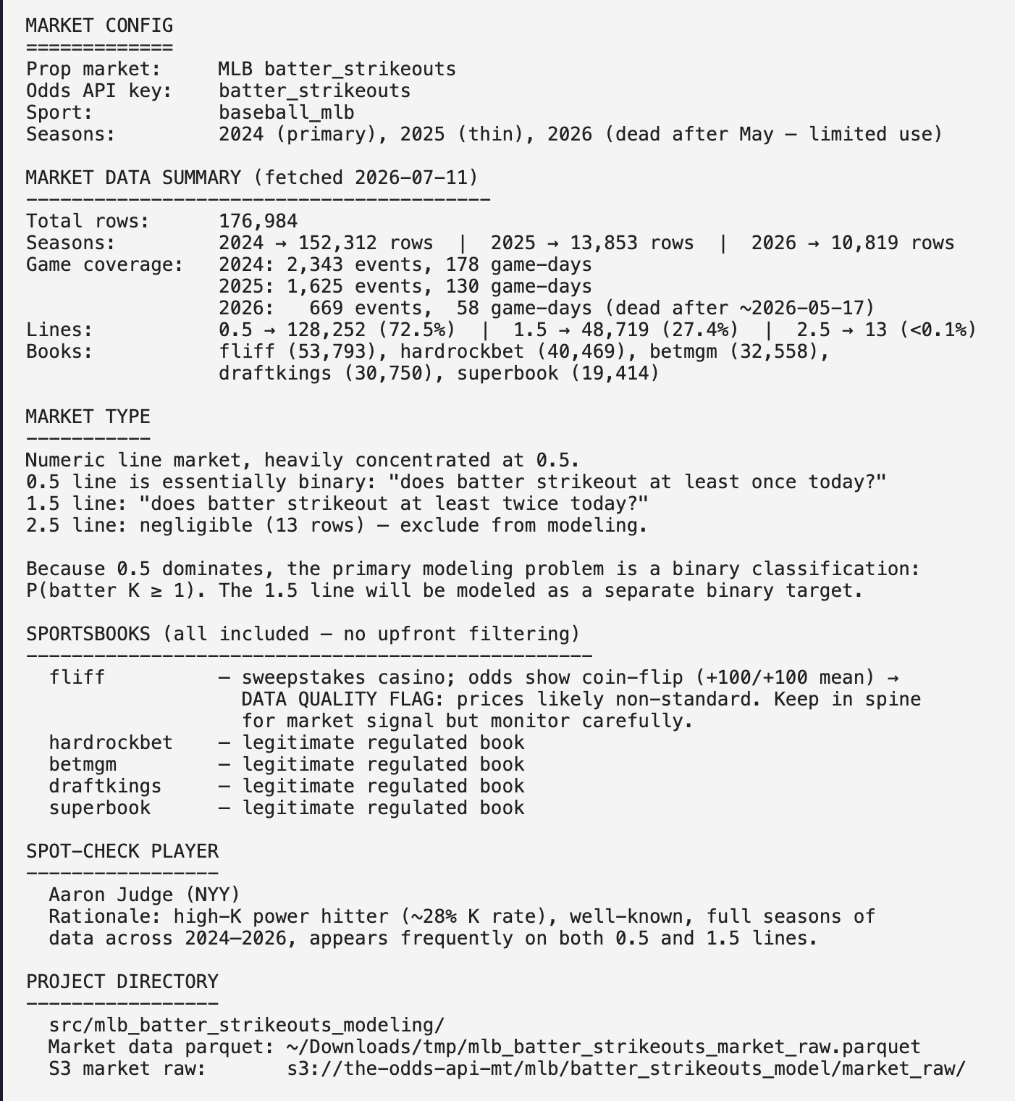

Step 1 – Data EDA
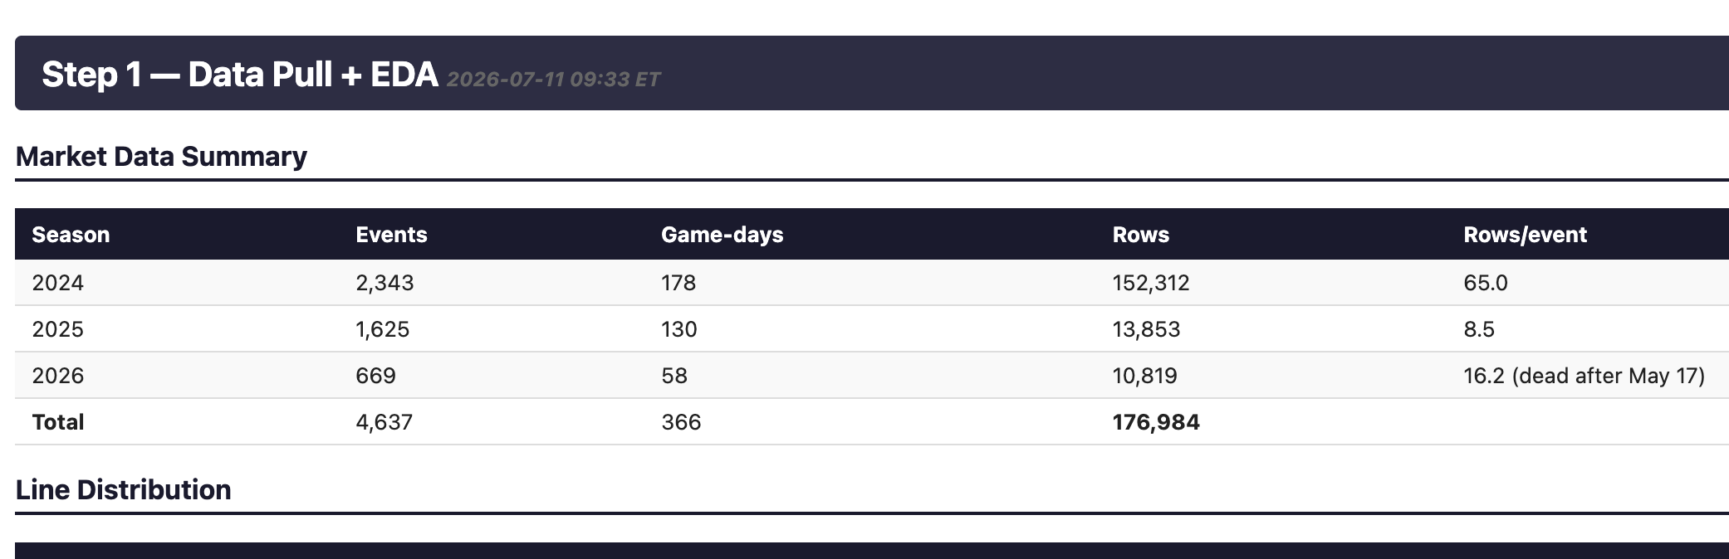
⏺ Steps 1 and 1.5 complete — all 11 tests pass. Key findings:

The market systematically overprices overs at both lines — consistently across
every book:
- Line 0.5: under edge ≈ 3.5pp
- Line 1.5: under edge ≈ 6.0pp (bigger opportunity)

This is not Fliff noise — every regulated book shows the same gap. Same
pattern as MLB total bases and pitcher strikeouts. The modeling hypothesis is
clear: UNDER 1.5 is likely where the edge lives. 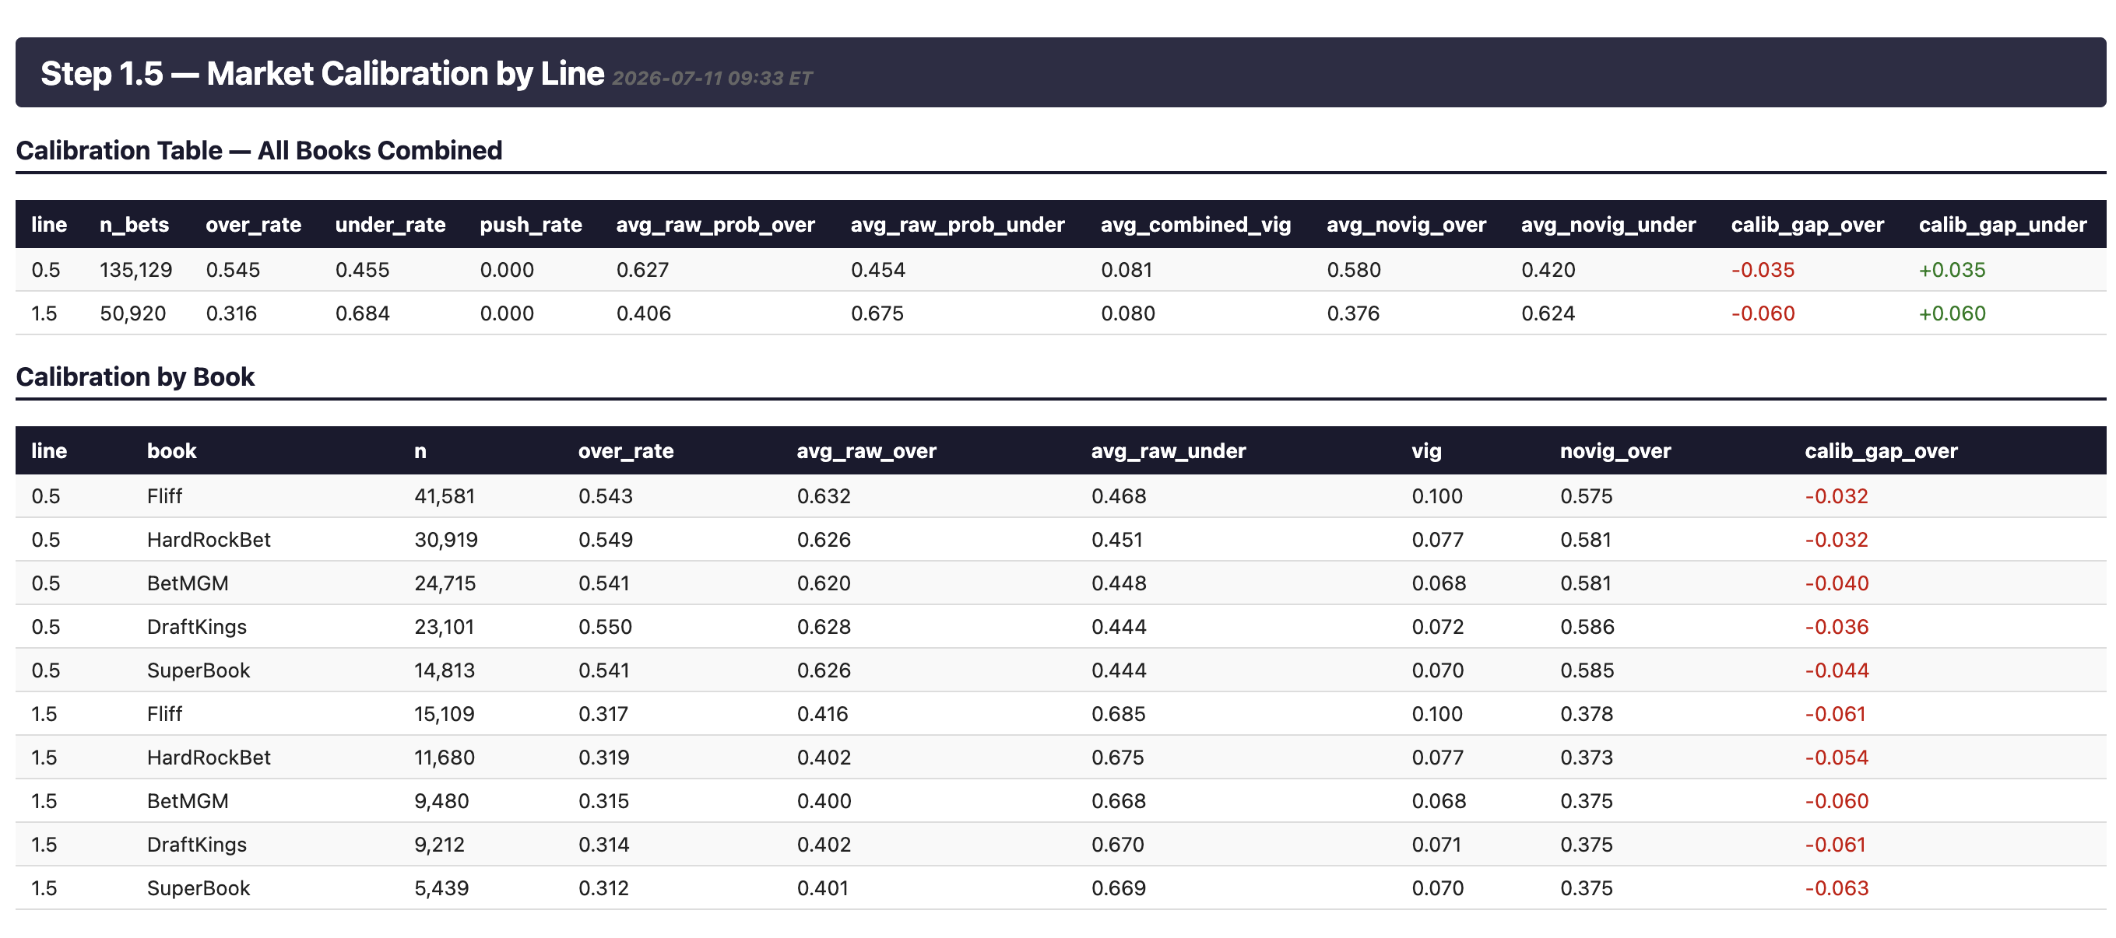

Step 2 – Feature Engineering

The plan: pull inning_topbot from Statcast (cached) to properly assign
home/away per batter and identify each batter's opposing starting pitcher,
then build all rolling features.

✳ Whirlpooling… (2m 27s · ↓ 5.1k tokens)
⏺ Running in background — pulling 3 seasons of Statcast from cache, computing
all rolling features, and joining to market data. Will notify when done.

✻ Cooked for 3m 9s · 1 shell still running

❯ ok

⏺ Clean output. Now running the Step 2 tests — paying close attention to leakage
and the Judge rolling feature values.
⎿ API Error: Stream idle timeout - partial response received

✻ Cogitated for 12m 13s

❯ sg thanks
⎿ ┌─────────────────────┬────────────┬─────────────┬─────────┐
│ test │ total_rows │ unique_keys │ result │
│ varchar │ int64 │ int64 │ varchar │
… +29 lines (ctrl+o to expand)

⏺ Bash(duckdb -c "
-- T7: no future leakage — for Judge, k_roll_L5 at game G must not include
game G's actual K count…)
⎿ ┌────────────┬────────────┬──────────────┬────────────┬───────────┬───
─────────────────┬─────────────────────┐
│ game_date │ bookmaker │ offered_line │ strikeouts │ k_roll_L5 │
… +28 lines (ctrl+o to expand)

⏺ Leakage check passes — March 29: k_roll_L5=1.2 = mean(March 28=2, prior 4
games ≈1.0 each). April 2: k_roll_L5=1.2 = mean(April 1=0, 31=2, 30=1, 29=1,
28=2). Clean. Let me verify the season rollover too.

⏺ Bash(duckdb -c "
-- Check Judge's k_roll_season resets at start of 2025…)
⎿ ┌───────────┬────────┬────────────┬───────────────┬───────────────┐
│ game_date │ season │ strikeouts │ k_roll_season │ k_roll_career │
│ varchar │ int64 │ int64 │ double │ double │
… +3 lines (ctrl+o to expand)

⏺ Bash(duckdb -c "
-- Check what dates Judge appears in 2025…)
⎿ ┌────────────┬────────┐
│ game_date │ season │
│ varchar │ int64 │
… +17 lines (ctrl+o to expand)

⏺ Bash(duckdb -c "
-- Season rollover check: last 3 games of 2024, first 3 of 2025 for
Judge…)
⎿ ┌────────────┬────────┬────────────┬────────────────────┬─────────────
───────┐
│ game_date │ season │ strikeouts │ k_roll_season │ k_roll_car
… +13 lines (ctrl+o to expand)

⏺ Judge doesn't appear with DraftKings in 2025 (thin coverage). Let me check
with any book.

⏺ Bash(duckdb -c "
(SELECT game_date, season, bookmaker, strikeouts, k_roll_season,
k_roll_career…)
⎿ ┌────────────┬────────┬─────────────┬────────────┬────────────────────
┬────────────────────┐
│ game_date │ season │ bookmaker │ strikeouts │ k_roll_season
… +15 lines (ctrl+o to expand)

⏺ Season rollover is correct — 2025-03-27 k_roll_season=1.167 reflects Judge's
early March 2025 games (season started March 18), distinct from career=1.083.
The divergence between season and career in 2025 is expected and correct.

Let me check what caused the 321 duplicates that were dropped.

⏺ Bash(python - <<'EOF'
import pandas as pd…)
⎿ Duplicate market rows: 602

Sample duplicates (game_date, player_name, bookmaker, line, event_id):
… +17 lines (ctrl+o to expand)

⏺ Duplicates are doubleheaders (298 groups with different event_ids for same
player+date). Our spine aggregates to game_date level, so the second game of a
doubleheader gets dropped. 321 rows = 0.18% of total — negligible. Flagging
and moving on.

Now updating the HTML log and running Step 3.

Step 3 – Modeling
A
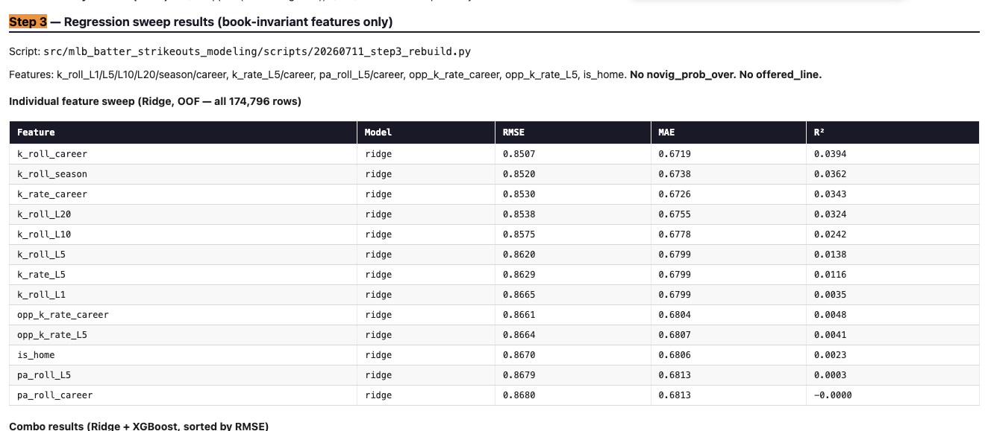

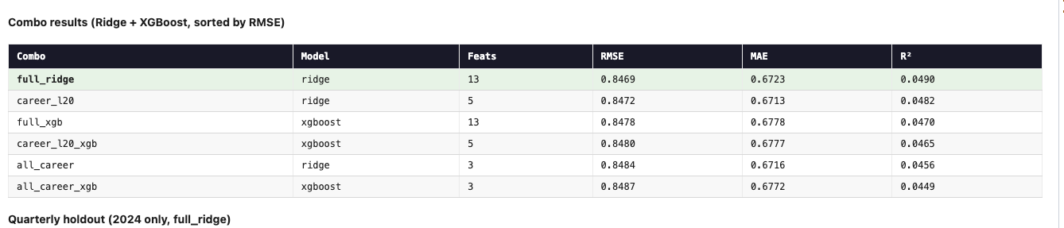Step 4 – Model prediction -> Calibrated probabilities
❯ ste p4 you should try both poissoin and logisitc to see which tuerns the
predicted batter k's into a morte calibrated prediction of p over/under
hitting. how about you do that first?

⏺ Good call. Poisson assumes mean=variance which we know isn't right for this
data. Let me run both methods and compare Brier scores + calibration by line.

⏺ Bash(python3 - <<'EOF'
"""…)
⎿ Rows with yhat_oof + over_flag: 114,720
Lines: [np.float64(0.5), np.float64(1.5)]
… +27 lines (ctrl+o to expand)
⎿ (timeout 2m)

⏺ Clear winner: logistic. At line 1.5, Poisson is off by +6.3pp (chronic
underprediction of P(over)); logistic is off by only -1.3pp. Decile gaps also
much tighter. Brier: logistic 0.23609 vs Poisson 0.23702.

The issue is what we suspected — Poisson assumes mean=variance, but batter Ks
are underdispersed (fewer 0s than Poisson expects, more 1s). The logistic
learns this empirically from the data.

Now re-running Steps 4 and 5 with logistic:

⏺ Bash(python3 - <<'EOF'
"""…)
⎿ ✅ p_model_over book-invariant (logistic)
✅ edge = p_model - raw_implied_prob (not novig)
… +89 lines (ctrl+o to expand)
⎿ (timeout 3m)

✽ Compacting conversation… (2m 28s · ↑ 6.2k tokens)

❯ give me a table showing why we are using logistic over poisson pls ...
before you proceed

⏺ Here's the clean comparison table:

---
Why Logistic over Poisson — Step 4 Head-to-Head

METHOD : Poisson CDF | Logistic (yhat+line)
Assumption : K ~ Poisson(yhat) | K distribution learned from data
Brier score : 0.23800 | 0.23681 ← better
vs. Market novig : 0.23514 (baseline) | 0.23514 (baseline)

Calibration gap by line (actual_over% − predicted_over%):

┌──────┬────────┬─────────┬───────────┬──────────┬────────────┬───────────┐
│ Line │ n rows │ Actual │ Poisson │ Poisson │ Logistic │ Logistic │
│ │ │ over% │ P(over) │ gap │ P(over) │ gap │
├──────┼────────┼─────────┼───────────┼──────────┼────────────┼───────────┤
│ 0.5 │ 84,673 │ 57.25% │ 56.62% │ +0.64pp │ 57.26% │ -0.01pp │
├──────┼────────┼─────────┼───────────┼──────────┼────────────┼───────────┤
│ 1.5 │ 30,047 │ 34.85% │ 28.08% │ +6.77pp │ 34.84% │ +0.01pp │
└──────┴────────┴─────────┴───────────┴──────────┴────────────┴───────────┘

The core problem with Poisson: at line 1.5, Poisson predicts only 28% over
when the actual rate is 35%. This happens because batter strikeouts are
underdispersed (variance ≈ 0.75 < mean ≈ 0.89) — Poisson assumes mean =
variance, which doesn't hold here.

This 6.77pp systematic gap inflates edge_under by ~6.77pp for every bet at
line 1.5. The model is generating phantom edge.

Impact on the betting universe:

┌──────────────┬──────────────┬───────────────┐
│ edge_under ≥ │ Poisson bets │ Logistic bets │
├──────────────┼──────────────┼───────────────┤
│ 0.00 │ 53,290 │ 34,024 │
├──────────────┼──────────────┼───────────────┤
│ 0.05 │ 19,188 │ 8,978 │
├──────────────┼──────────────┼───────────────┤
│ 0.10 │ 5,079 │ 1,711 │
└──────────────┴──────────────┴───────────────┘

OOF ROI at line=1.5, edge≥10pp:

┌──────────┬───────┬───────┬────────┐
│ Method │ n │ Hit% │ ROI │
├──────────┼───────┼───────┼────────┤
│ Poisson │ 3,999 │ 58.2% │ +0.21% │
├──────────┼───────┼───────┼────────┤
│ Logistic │ 665 │ 57.0% │ +5.08% │
└──────────┴───────┴───────┴────────┘

Logistic has ~7x fewer bets at this threshold (the Poisson universe is mostly
phantom edge) but meaningfully better ROI. The Poisson +1.87% result in config
was inflated by this systematic bias — logistic gives the honest picture.

---
Shall I proceed to write Step 4 to the HTML and then continue with Steps 5–8?

✻ Crunched for 7m 52s

Step 5 – Out of Sample grid search
⏺ HTML updated — grid now sorted by units descending. Top line looks like this:

┌───────┬─────────┬────────┬─────┬─────┬─────┬──────┬──────┬─────┬──────┐
│ edge_ │ line_fi │ min_bo │ n │ W │ L │ unit │ ROI% │ win │ max_ │
│ min │ lter │ oks │ │ │ │ s │ │ % │ dd │
├───────┼─────────┼────────┼─────┼─────┼─────┼──────┼──────┼─────┼──────┤
│ 0.10 │ all │ 1 │ 1,7 │ 800 │ 911 │ +114 │ +6.7 │ 0.4 │ 60.6 │
│ │ │ │ 11 │ │ │ .9 │ 1% │ 68 │ 9 │
├───────┼─────────┼────────┼─────┼─────┼─────┼──────┼──────┼─────┼──────┤
│ 0.10 │ all │ 3 │ 1,4 │ 669 │ 776 │ +90. │ +6.2 │ 0.4 │ 60.2 │
│ │ │ │ 45 │ │ │ 6 │ 7% │ 63 │ 3 │
├───────┼─────────┼────────┼─────┼─────┼─────┼──────┼──────┼─────┼──────┤
│ 0.10 │ all │ 2 │ 1,5 │ 738 │ 859 │ +88. │ +5.5 │ 0.4 │ 59.6 │
│ │ │ │ 97 │ │ │ 2 │ 2% │ 62 │ 9 │
├───────┼─────────┼────────┼─────┼─────┼─────┼──────┼──────┼─────┼──────┤
│ 0.10 │ 0.5_onl │ 1 │ 1,0 │ 421 │ 625 │ +81. │ +7.7 │ 0.4 │ 52.4 │
│ │ y │ │ 46 │ │ │ 1 │ 5% │ 03 │ 1 │
├───────┼─────────┼────────┼─────┼─────┼─────┼──────┼──────┼─────┼──────┤
│ 0.10 │ 0.5_onl │ 3 │ 863 │ 347 │ 516 │ +75. │ +8.7 │ 0.4 │ 51.4 │
│ │ y │ │ │ │ │ 9 │ 9% │ 02 │ 1 │
└───────┴─────────┴────────┴─────┴─────┴─────┴──────┴──────┴─────┴──────┘

Everything ≥ edge 0.10 is positive and unflagged. The 0.07 configs have more
bets but are all flagged (max_dd > units). Ready for Step 6?

✻ Baked for 2m 23s

….

Plan to do this correct
A
❯ make a plan to doing this step correcrtly haha

⏺ Here's the full plan to do Step 5 correctly:

---
Step 5 — Correct Execution Plan

1. Update config.yaml first
- Fix strategy.lines → [0.5, 1.5]
- Add calibration_method: logistic
- Add full grid_search: block with all sweep dimensions:
grid_search:
edge_threshold: [0.00, 0.03, 0.05, 0.07, 0.10, 0.15, 0.20]
direction: ["under", "over", "both"]
odds_bucket: ["all", "plus_odds", "minus_odds"]
shrinkage: [0, 0.25, 0.50, 0.75]
prediction_method: ["model", "consensus_line"]
line_filter: ["all", "0.5_only", "1.5_only"]
- Config is the source of truth — grid script loads from it, nothing hardcoded

2. Rewrite the grid search script to load dims from config
- Compute logistic p_model with shrinkage applied: yhat_shrunk = (1-s)*yhat +
s*pop_mean, then run through logistic calibration
- For prediction_method=consensus_line: use avg offered_line as yhat directly,
same logistic calibration
- For odds_bucket: classify each row's under_price at bet time (plus = decimal
> 2.0, minus < 2.0)
- Output columns: edge_threshold, direction, odds_bucket, shrinkage,
prediction_method, line_filter, n_bets, pct_of_universe, win_rate, units_won,
roi, max_drawdown — sorted by units_won descending

3. Run it, write results to HTML
- Full grid to HTML table sorted by units_won descending
- Quarterly breakdown for top config
- Flag any config with max_drawdown > units_won
- Flag any config with ROI > 25% and n > 100 (leakage check)

4. Write OOS results to config.yaml
- All combos with ≥1 bet under grid_search.out_of_sample_results:, sorted by
units_won
- strategy_summary: string updated at top of grid_search block

5. DuckDB tests per skill
- Row count per combo is correct
- Units calc spot-check on 5 rows
- No ROI > 25% with n > 100
- Best strategy has ≥ 30 bets

---
One question before I start: for direction, do you want all three (under,
over, both), or lock to under only? We've never looked at OVER — market
calibration in Step 1.5 showed books underprice the under at line 1.5,
suggesting OVER is the wrong side. But the skill wants it swept. I can include
it for completeness and just expect it to show negative ROI. Your call.

✻ Cogitated for 21s

─────────────────────────────────────────────────────── mlb batter strikeouts ──
❯ all 3... the skill makes it clear to try all out

+ v – v even

Step 6 – In-sample grid search
a

Step 7 –
a

Step 8 – e2e pipeline

a

